Schema Design

Pictorial representation of database.

Scaler Case Study

1. There are several batches at scaler. Each batch has id, name, current instructor.
2. Each batch has multiple classes. Each class has id, name and instructor.
3. Every student has id, name, email, graduation year etc.
4. A student can move from one batch to another batch via pausing. We need to store entry and exit date of students related to each batch they were part of.
5. Each student has a mentor. Every mentor has name and date of birth.
6. Every instructor has name and date of birth.

Step Based Process

1. Handle Entities
2. Handle Relationships

Handle Entities

1. Identify Nouns in requirements.
2. If we are storing some information about it, create a table for it.

Scaler Case Study

1. There are several batches at scaler. Each batch has id, name, current instructor.
2. Each batch has multiple classes. Each class has id, name and instructor.
3. Every student has id, name, email, graduation year etc.
4. A student can move from one batch to another batch via pausing. We need to store entry and exit date of students related to each batch they were part of.
5. Each student has a mentor. Every mentor has name and date of birth.
6. Every instructor has name and date of birth.

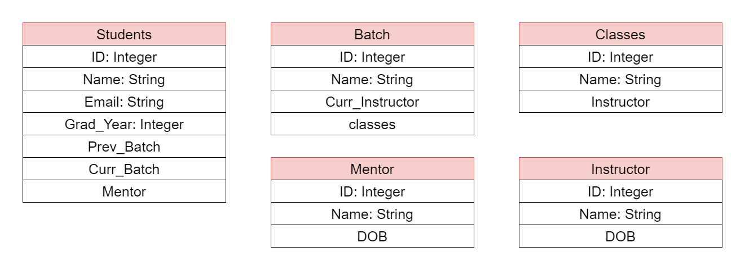

Handle Relationships

1. Identify Relationships.
2. Identify Cardinality.

Process to determine Cardinality

1. Approach from both sides.

Cardinality: Cardinality tells us how many of one entity is related to how many of other entity.

One student can part of how many batches?

Ans: 1

One Batch can have how many students?

Ans: Many

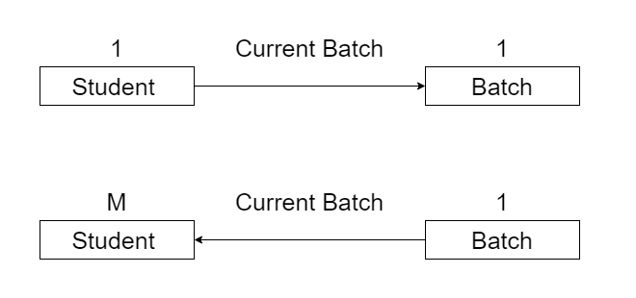

Now, take maximum from both sides. i.e. M:1. Therefore, relationship from student to Batch is M:1.

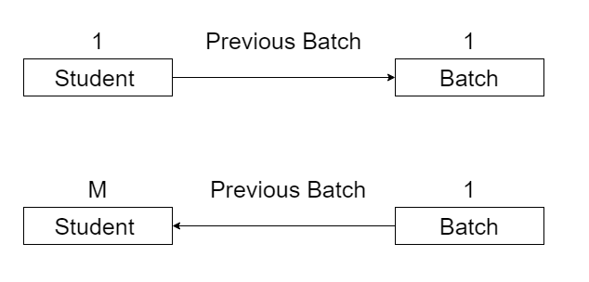

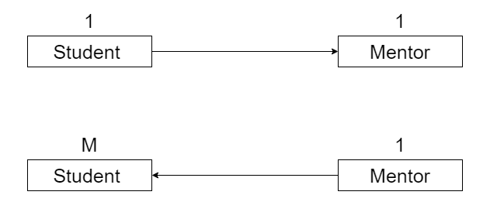

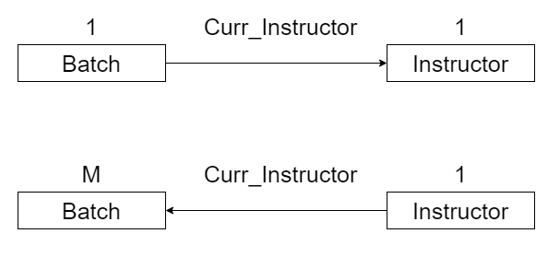

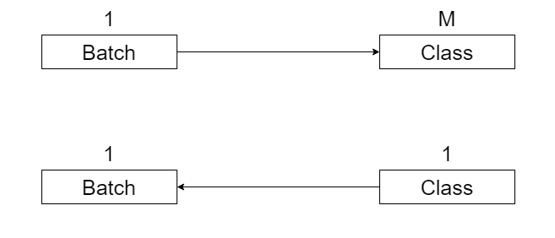

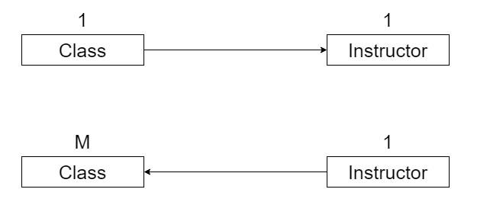

How to model different cardinalities?

1:1

Husbands

|  |  |  |  |  |
| --- | --- | --- | --- | --- |
| Id |  |  |  |  |
|  |  |  |  |  |
|  |  |  |  |  |

Wives

|  |  |  |  |  |
| --- | --- | --- | --- | --- |
| Id |  |  |  | HID |
|  |  |  |  |  |
|  |  |  |  |  |

Options

1. Put husband id in wives table.
2. Put wife id in husbands table.

1:M

Batches

|  |  |  |  |  |
| --- | --- | --- | --- | --- |
| Id |  |  |  |  |
|  |  |  |  |  |
|  |  |  |  |  |

Classes

|  |  |  |  |  |
| --- | --- | --- | --- | --- |
| Id |  |  |  | BID |
|  |  |  |  | 1 |
|  |  |  |  | 2 |

Options

1. Store batch id in classes table.

M:1

Current Batch

Batches

|  |  |  |  |  |
| --- | --- | --- | --- | --- |
| Id |  |  |  |  |
|  |  |  |  |  |
|  |  |  |  |  |

Students

|  |  |  |  |  |
| --- | --- | --- | --- | --- |
| Id |  |  |  | BID |
|  |  |  |  | 1 |
|  |  |  |  | 2 |

Options

1. Store batch id in students table.

M:M

Previous Batch

Students

|  |  |  |  |  |
| --- | --- | --- | --- | --- |
| Id |  |  |  |  |
|  |  |  |  |  |
|  |  |  |  |  |

Batches

|  |  |  |  |  |
| --- | --- | --- | --- | --- |
| Id |  |  |  |  |
|  |  |  |  |  |
|  |  |  |  |  |

Options

1. Create Mapping table and stick with composite key.
2. Create Mapping table and add a new id column as primary key.

Students-Previous-Batches

|  |  |
| --- | --- |
| SID | PBID |
| 1 | 127 |
| 1 | 1045 |
| 1 | 1896 |
| 2 | 188 |
| 2 | 256 |
| 2 | 10450 |

Here SID, PBID together makes a composite key.

Here data is first stored by SID then it is stored by PBID.

Students-Previous-Batches

|  |  |  |
| --- | --- | --- |
| ID | SID | PBID |
| 1 | 1 | 4 |
| 2 | 1 | 10 |

Create Mapping table and add a new id column as primary key.

1. Mapping table starts acting like an entity.

|  |  |  |  |  |
| --- | --- | --- | --- | --- |
| ID | SID | PBID | PB_start_date | PB_start_date |
| 1 | 25 | 1 | 16th Aug, 2022 | 18th Sep, 2022 |
| 2 | 25 | 2 | 25th Nov, 2022 | 3rd Mar, 2023 |

1. When mapping table wants to create relationship with other table.

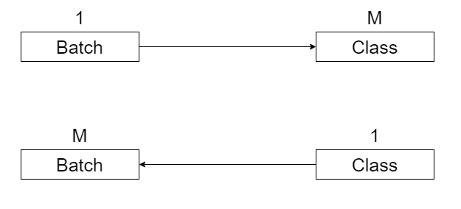

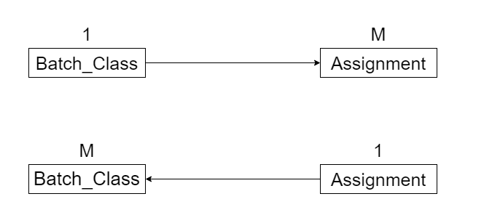

Batch-Class

|  |  |  |
| --- | --- | --- |
| ID | BID | CID |
|  |  |  |
|  |  |  |

Batch-Class-Assignment with dedicated ID

|  |  |
| --- | --- |
| BCID | AID |
|  |  |
|  |  |

Batch-Class-Assignment with composite key

|  |  |  |
| --- | --- | --- |
| BID | CID | AID |
|  |  |  |
|  |  |  |

Batch-Class-Assignment with dedicated ID is more easier to join.

Caveats

1. Sparse tables.

1:1

Husbands

|  |  |  |  |  |
| --- | --- | --- | --- | --- |
| Id |  |  |  | WID |
|  |  |  |  |  |
|  |  |  |  |  |

Wives

|  |  |  |  |  |
| --- | --- | --- | --- | --- |
| Id |  |  |  |  |
|  |  |  |  |  |
|  |  |  |  |  |

Suppose we have 100 million husbands and 1 million wives then at max 1 million marriages are possible. When we store wife id in husband table there will be at least 99 million spare entries. Thus, we are wasting 396mb memory.

We can create Mapping Table instead of storing id.

Husband-Wife

|  |  |
| --- | --- |
| HID | WID |
|  |  |
|  |  |

1:M or M:1



Students

|  |  |  |  |
| --- | --- | --- | --- |
| ID | Name | Email | Curr_BID |
|  |  |  |  |
|  |  |  |  |
|  |  |  |  |

Now, Suppose scaler takes a master class and 25k enrolled with master class. Out of 25k, 1k registers with scaler. This will results in 24k nulls. So, Here also we can create mapping table.

Students

|  |  |  |
| --- | --- | --- |
| ID | Name | Email |
|  |  |  |
|  |  |  |
|  |  |  |

Students-Current-Batch

|  |  |
| --- | --- |
| SID | CBID |
|  |  |
|  |  |
|  |  |

1:1

Wife

|  |  |
| --- | --- |
| ID | Name |
|  |  |
|  |  |
|  |  |

Husband

|  |  |  |  |  |  |
| --- | --- | --- | --- | --- | --- |
| ID | Name | WID | Marriage_date | Marriage_city | Honeymoon_city |
|  |  |  |  |  |  |
|  |  |  |  |  |  |
|  |  |  |  |  |  |

Wife

|  |  |
| --- | --- |
| ID | Name |
|  |  |
|  |  |
|  |  |

Husband

|  |  |
| --- | --- |
| ID | Name |
|  |  |
|  |  |
|  |  |

Husband-Wife-Marriage

|  |  |  |  |  |  |
| --- | --- | --- | --- | --- | --- |
| ID | HID | WID | Marriage_date | Marriage_city | Honeymoon_city |
|  |  |  |  |  |  |
|  |  |  |  |  |  |
|  |  |  |  |  |  |

1:M or M:1

Student

|  |  |  |  |
| --- | --- | --- | --- |
| ID | Name | CBID | Curr_batch_joining_date |
|  |  |  |  |
|  |  |  |  |
|  |  |  |  |

Student

|  |  |
| --- | --- |
| ID | Name |
|  |  |
|  |  |
|  |  |

Batch

|  |  |
| --- | --- |
| ID | Name |
|  |  |
|  |  |
|  |  |

Student-Batch

|  |  |  |  |
| --- | --- | --- | --- |
| ID | SID | CBID | Curr_batch_joining_date |
|  |  |  |  |
|  |  |  |  |
|  |  |  |  |

|  |  |  |  |
| --- | --- | --- | --- |
| Condition | Normal | Caveat#1 Sparse Table | Caveat#2 Relationship becomes entity |
| Cardinality |  |  |  |
| 1:1 | Put id of any side on other side | Mapping Table | Mapping Table |
| 1:M or M:1 | Put id of 1 side on M side | Mapping Table | Mapping Table |
| M:M | Mapping Table | Mapping Table | Mapping Table |

Final Scaler Schema Design

